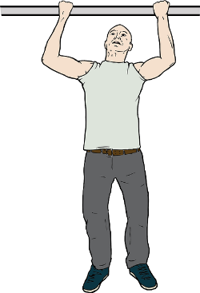 **BAR DRILLS - FOR HOME CONDITIONING**

**Use pull up bar (if you have one) or frame of a swing (if you can take the swing off)**

Helping you keep your upper body strength whilst you practice at home

1. *Forward Grip 10 chin ups*
2. *Reverse Grip 10 chin ups*
3. *Mixed Grip 10 chin ups*
4. *Leg Lifts (straight legs) x 10*
5. *Tuck Shape, Pike Shape, Straddle Shape and W Shape holds for 5 seconds each - (no stops in between each shape)*
6. *Window wipers x 10 (hang on bar, with straight legs bring feet up to the bar. Staying in this pike shape, move your hips so your feet go over your left hand and then your right hand)*
7. *Through the Window. Hold legs straight in upside down pike come down and repeat x 5*
8. *Chin Circles (upward circle to front support and forward down to hang and back up again to front support) x 5*
9. *Rotation Chin ups: Hang on bar forward grip, change left hand to reverse grip and then move right hand around to rotate body so both hands are now in forward grip, do 2 Chin ups before repeating the other way. X 4*
10. *Hanging sit ups x 10. Hook knees over the bar (see if someone can hold your feet) Hands by your head or across chest and sit up to face your knees.*