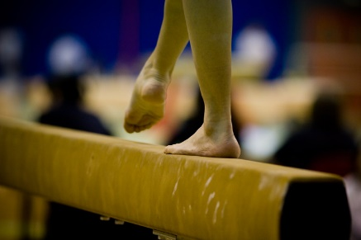 **BEAM COMPLEXES - LINE WORK**

**Use floor beam (if you have one); a low border wall, or even a line stuck down with masking tape**

Helping you keep your balance and tightness whilst you practice at home

1. *Hands behind head push elbows back walk tall on toes*
2. *Small dip, lift leg to horizontal keeping supporting leg’s foot flat on beam - repeat on other leg…*
3. *Small dip, lift leg higher than horizontal and go up on toes of supporting leg - repeat…*
4. *Face sideways and on toes walk to one end and come back*
5. *Facing sideways, bring one leg over the other, step out and then bring the leg/foot behind the other and then come back*
6. *Arms out to side, large lunge forward so back knee touches beam, kick up back leg and repeat…*
7. *Arms straight up by ears, take 3 steps, stand on one leg with foot of other leg by knee. Elevate up on toes x 3 before taking 3 steps to repeat on other leg. Repeat…*
8. *Arms out, leading with knee bring it across body then back out to the side and lift high. Repeat…*
9. *Hands on Hips. Continuous Rebound jumps - keep tight and point toes.*
10. *Walk 3 steps ½ spin into a pivot turn - repeat*
11. *Walk 3 steps Full Turn and back ½ or full spin*
12. *Chasee cat leap and maybe try catleap with ½ turn*
13. *Split leaps, W jumps, sissones etc.*
14. *Practice rolls, cartwheels and walkovers, flics*